The Auto-Calculator of the Graphic y-axis Tickvaluelist, Tickvalueformat with Expected Values for SAS Data Visualizations Part II
Kaiqing Fan
Mastech Digital Inc.
Abstract
When we plot graphics using SAS PROC TEMPLATE or PROC GPLOT or other procedures, we need to decide the x-axis and y-axis tick-value list. However when we plot hundreds or thousands line, bar graphics using SAS, how could we automatically calculate the y-axis tick-values is a huge challenge. My sub-engine can automatically calculate and provide nice y-axis tick-values for sets of minimum and maximum values. Once you decide the minimum and maximum values among a set of numbers, you can use this sub-engine to automatically calculate your x-axis and y-axis tick-values including yaxisopts tickvaluelist, yaxisopts tickvalueformat, barchart statement barlabelformat, referenceline curvelabel, xaxisopts tickdisplaylist and xaxisopts tickvaluelist, and more when you use PROC TEMPLATE, PROC GPLOT or other procedures.
COMMENTS: I finished three SAS Papers about data visualizations.
But only the 3rd one was accepted by SAS Global Forum 2018 as e-poster. Acutally, the 3rd one was based on the 1st and 2nd papers. This is the 2nd paper.
Here is the one accepted by SASGF2018. Its paper number is 2545-2018
Some Tricks and Explanations When Plotting Graphic Images Using PROC TEMPLATE SAS® Enterprise Guide Part III

Introduction
When we use SAS PROC TEMPLATE or other procedures to draw bars, lines and other graphics, we need to manually decide their y-axis tick-values. But when we draw hundreds of thousands graphics, it is impossible to manually calculate these y-axis tick-values, we need to develop an automatic calculator of the graphic y-axis tick-values. How nice would these y-axis tick-values look like? The following is the list of examples:
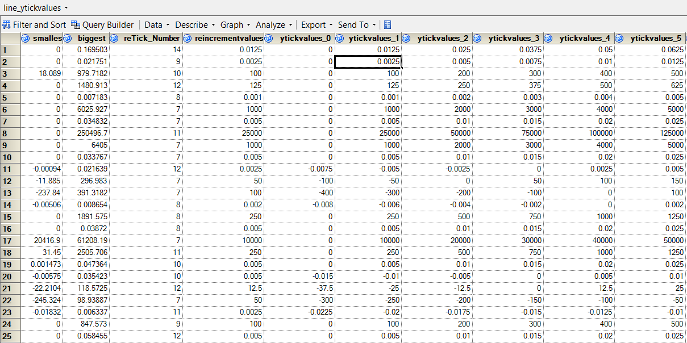
The Features of the Calculator
Here are the features:
1, the increment values are 1, 1.25, 2, 2.5, 5, 10 … and their … 0.0001, 0.001, 0.01, 1, 10, 100, 1000 … times; it is easy to count with mind only.
2, the number of grids are between 6 and 15, we can make this number smaller if need;
3, the gaps between maximum value and the upper-band are no more than 2 or 3 times of increment values;
4, the gaps between minimum value and the low-band are no more than 2 or 3 times of increment values except that the low_band is 0;
5, the y-axis tick-values are always including 0 value;
6, the biggest and smallest values are always covered by the up and low bands;
7, This calculator will automatically calculate and define the parameters of yaxisopts origin, yaxisopts viewmin, yaxisopts tickvaluelist, yaxisopts tickvalueformat, barchart statement barlabelformat, referenceline curvelabel, xaxisopts tickdisplaylist and xaxisopts tickvaluelist.
In the calculator engine, we call them as
%GLOBAL ytickvaluelist_&page._&postn
ytickdisplaylist_&page._&postn (you can add it into the engine by yourself)
xtickvaluelist_&page._&postn
xtickdisplaylist_&page._&postn
curvelabel_&page._&postn
tickvalueformat_&page._&postn
origin_&page._&postn
xtickvaluelist_&page._&postn
xtickdisplaylist_&page._&postn ;

8, the tickvalueformat_&page._&postn will make all values in the image with same format, please see the first graphics.

Attached EXCEL file 6_line_ytickvalues.xlsx contains more than 210 examples of minimum and maximum values as biggest and smallest in the left two columns, and their y-axis tick-values. If interested, please feel free to review them by yourself.

These features can guarantee the y-axis tick-values look very nice like the following two graphic images: one is bar chart, another is line chart.
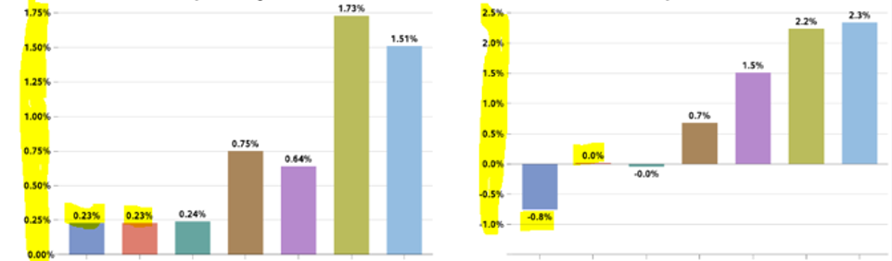
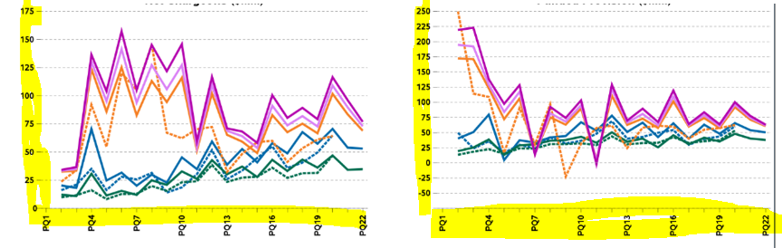
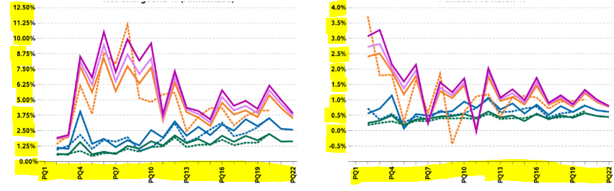
Why would we like to calculate y-axis tick-values like the above? I think we should make the above y-tick-values as easy and friendly as possible to be read by users, leaders, decision-makers.

The SAS y-axis Tick Values Auto-Calculator Engine
To make the engine as clear as possible, I add some needed comments as the explanation of its logic here. It is an engine calculator of 1 page with 4 images.
The data example is line0_5_ll table with the following data structure:

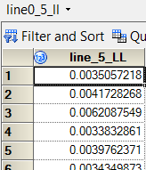
%let page = 5;
%macro yaxis_tickvalue_calculator(postn=);
%GLOBAL ytickvaluelist_&page._&postn ytickdisplaylist_&page._&postn
curvelabel_&page._&postn tickvalueformat_&page._&postn origin_&page._&postn ;

/*pick the min and max values from data line0_&page._&postn*/
proc sql;
select distinct MIN(line_&page._&postn), MAX(line_&page._&postn)
into :minPQ, :maxPQ from line0_&page._&postn;
quit;

/*******calculate the lengths of min and max before decimal point****/
/*if both their absolute values are less than 1, times with 1000 or 100*/
data line1_&page._&postn;
length maxPQ $50. minPQ $50.;
%if %sysfunc(abs(&minPQ))<1 and %sysfunc(abs(&maxPQ))<1 %then %do;

%let scale = 0.0000001;
maxPQ=%SYSEVALF(&maxPQ/&scale,ceil); minPQ=%SYSEVALF(&minPQ/&scale,ceil);
%end;
%else %do;
maxPQ=%sysfunc(round(&maxPQ,1)); minPQ=%sysfunc(round(&minPQ,1));
%end;
length_max = length(strip(tranwrd(maxPQ,'-',''))); length_min = length(strip(tranwrd(minPQ,'-','')));
call symput('lengthmax',length_max); call symput('lengthmin',length_min);
run;

/*decide the incremental values, tick count number*/
data line2_&page._&postn; /*decide max and min value’s digit level as 1, 10, 100, 1000, 10000 …*/
%if %sysfunc(abs(&minPQ))<1 and %sysfunc(abs(&maxPQ))<1 %then %do;
max_digit=%SYSEVALF((10**(&lengthmax-1))*&scale);
min_digit=%SYSEVALF((10**(&lengthmin-1))*&scale); %end;
%else %do; max_digit=%eval(10**(&lengthmax-1)); min_digit=%eval(10**(&lengthmin-1)); %end;
if max_digit >= min_digit then digit_level = max_digit;
if max_digit < min_digit then digit_level = min_digit;
/*decide the min as upper band*/ minPQ=&minPQ/digit_level;
if minPQ <0 then round_min=floor(minPQ); if minPQ>=0 then round_min=ceil(minPQ);
minmmPQ=round_min*digit_level; if minmmPQ<0 then minimumPQ=minmmPQ;
if minmmPQ>=0 then minimumPQ=0; call symput('min_value',minimumPQ);
/*decide the max as upper band*/ maxPQ=&maxPQ/digit_level;
if maxPQ <0 then round_max=floor(maxPQ); if maxPQ>=0 then round_max=ceil(maxPQ);
maxmmPQ=round_max*digit_level; if maxmmPQ<0 then maximumPQ=0;
if maxmmPQ>=0 then maximumPQ=maxmmPQ; call symput('max_value',maximumPQ);
/*decide the incremental values*/
%if %sysfunc(abs(&minPQ))<1 and %sysfunc(abs(&maxPQ))<1 %then %do;
if &lengthmax>=&lengthmin then incremental=%SYSEVALF((10**(&lengthmax-1))*0.01);
if &lengthmax<&lengthmin then incremental=%SYSEVALF((10**(&lengthmin-1))*0.01); %end;
%else %do; if &lengthmax>=&lengthmin then incremental=%eval(10**(&lengthmax-1));
if &lengthmax<&lengthmin then incremental=%eval(10**(&lengthmin-1)); %end;
/*control the tick count numbers, if it is too large, divided by dividers*/
if 12<(maximumPQ-minimumPQ)/incremental then divider=.5;
if 6<(maximumPQ-minimumPQ)/incremental<13 then divider=1;
if 3<(maximumPQ-minimumPQ)/incremental<7 then divider=2;
if 1 < (maximumPQ-minimumPQ)/incremental <4 then divider=4;
if 0=< (maximumPQ-minimumPQ)/incremental <2 then divider=10;
/*recalculate the incremental values*/
incremental_value=incremental/divider; call symput('incremental',incremental_value);
/*decide the tick count number*/ Tickcount=(maximumPQ-minimumPQ)/incremental_value;
TickdigitNumber=ceil(Tickcount); call symput('Tickcount',TickdigitNumber);
run;

/*if min is positive, then reset it as 0, or as itself, if max is negative, then reset it as 0, or as itself*/
%if %index("&min_value",-)=0 %then %do; %let startvalue=0; %end;
%if %index("&min_value",-)>0 %then %do; %let startvalue=&min_value; %end;
%if %index("&max_value",-)>0 %then %do; %let endvalue=0; %end;
%if %index("&max_value",-)=0 %then %do; %let endvalue=&max_value; %end;

/*rescaling y-tickvalues because there may be lots of blank grids*/
/**** above max value to top or below min value to bottom ****/
data line3_ytickvalue_&page._&postn;
retain smallest biggest upper lower upper_blank_grids
lower_blank_grids rescaling_upper_number rescaling_lower_number
incremental_value tickvalues_:;
set line2_&page._&postn;
smallest=&minPQ; biggest=&maxPQ; tickvalues_0=&startvalue;
%do z=1 %to &Tickcount; tickvalues_&z=tickvalues_0+%SYSEVALF(&incremental*&z); %end;
upper = tickvalues_%sysfunc(left(&Tickcount));
upper_blank=(upper-biggest)/incremental_value;
upper_blank_grids=int(upper_blank);
lower = tickvalues_0;
lower_blank=(smallest-lower)/incremental_value;
lower_blank_grids=int(lower_blank);
rescaling_upper_number=TickdigitNumber-upper_blank_grids;
rescaling_lower_number=lower_blank_grids;
call symput('rescaling_upper_number',strip(rescaling_upper_number));
call symput('rescaling_lower_number',strip(rescaling_lower_number));
run;

/*remove those blank grids, then recalculate, recalculate the incremental values, tick count number*/
data line4_UpLw_Ytickval_&page._&postn (keep=smallest biggest lower_band upper_band reTickdigitNumber reTick_Number reTickcount reTickcount_number reincremental_value
redivider multiplier incremental_value reincrementvalues);
retain smallest biggest lower_band upper_band reTickdigitNumber reTick_Number reTickcount reTickcount_number reincremental_value redivider multiplier incremental_value reincrementvalues;
set line3_ytickvalue_&page._&postn;
if biggest<0 then do; lower_band=tickvalues_&rescaling_lower_number; upper_band=0; end;
else if smallest>0 then do; upper_band=tickvalues_&rescaling_upper_number; lower_band=0; end;
else do;
upper_band=tickvalues_&rescaling_upper_number;
lower_band=tickvalues_&rescaling_lower_number;
end;
if 12< (upper_band-lower_band)/incremental_value then redivider=.5;
if 6<(upper_band-lower_band)/incremental_value<13 then redivider=1;
if 3 < (upper_band-lower_band)/incremental_value <7 then redivider=2;
if 1<(upper_band-lower_band)/incremental_value<4 then redivider=4;
if 0=< (upper_band-lower_band)/incremental_value <2 then redivider=10;
reincremental_value=incremental_value/redivider;
reTickcount=(upper_band-lower_band)/reincremental_value;
reTickdigitNumber=ceil(reTickcount);
if reTickdigitNumber < 15 then multiplier=1;
if 14<reTickdigitNumber<28 then multiplier=2;
if 27<reTickdigitNumber then multiplier=3;
reincrementvalues=reincremental_value*multiplier;
reTickcount_number=(upper_band-lower_band)/reincrementvalues;
reTick_Number=ceil(reTickcount_number);
call symput('reincremental',strip(reincrementvalues));
call symput('reTickcount',strip(reTick_Number));
run;

/*use the reincrementvalues and reTick_Number to calculate each y-tick value*/
data line5_ytickval0_&page._&postn;
retain smallest biggest lower_band upper_band reTickdigitNumber reTick_Number reTickcount reTickcount_number reincremental_value redivider multiplier incremental_value reincrementvalues ytickvalues_:;
set line4_UpLw_Ytickval_&page._&postn;
%if %index("&min_value",-)>0 %then %do; /*** if min value is negative ***/
ytickvalues_0=lower_band-&reincremental; /*we always add one grid blank*/
%do z=0 %to &reTickcount+1; /*it is minus one increment value*/
ytickvalues_&z=ytickvalues_0+%SYSEVALF(&reincremental*&z);
%end;
%end;
%else %do; ytickvalues_0=lower_band;
%do z=0 %to &reTickcount; ytickvalues_&z=ytickvalues_0+%SYSEVALF(&reincremental*&z); %end;
%end;
run;

proc transpose data=line5_ytickval0_&page._&postn out =line6_check0_&page._&postn;
var ytickvalues_:;
run;

/* there may be some very small values, but show as 0 */
data line6_check0_&page._&postn;
set line6_check0_&page._&postn;
if 0.00000000001>COL1> -0.00000000001 then COL1=0;
run;

proc sort data=line6_check0_&page._&postn; by COL1; run;
proc sql; select distinct COL1 into :check_zero separated by 'a a' from line6_check0_&page._&postn;
quit; %put &check_zero;

/*check whether ytickvalues include 0, if no 0, then add 0 into y-tick values*/
%if %index("a&check_zero.a",a0a) = 0 %then %do;
data line6_ytickval1_&page._&postn;
set line5_ytickval0_&page._&postn;
low_ticknum = (0-ytickvalues_0)/reincrementvalues;
low_ticknumber = ceil(low_ticknum);
up_ticknum = (0+ytickvalues_%eval(&reTickcount+1))/reincrementvalues;
up_ticknumber = ceil(up_ticknum);
call symput('low_ticknumber',low_ticknumber);
call symput('up_ticknumber',up_ticknumber);
drop ytickvalues_:;
run;

data line7_ytickval_&page._&postn;
retain smallest biggest lower_band upper_band reTickdigitNumber
reTick_Number reTickcount reTickcount_number reincremental_value
redivider multiplier incremental_value reincrementvalues low_ticknumber
up_ticknumber ytickvalues_:;
set line6_ytickval1_&page._&postn;
%do f = 0 %to &low_ticknumber;
ytickvalues_low_&f = -%SYSEVALF(&reincremental*&f);
%end;
%do k = 0 %to &up_ticknumber;
ytickvalues_up_&k = %SYSEVALF(&reincremental*&k);
%end;
call symput("origin_&page._&postn",ytickvalues_low_%left(&low_ticknumber.));
run;
%end;
%else %do;
data line7_ytickval_&page._&postn;
retain smallest biggest lower_band upper_band reTickdigitNumber reTick_Number
reTickcount reTickcount_number reincremental_value redivider multiplier
incremental_value reincrementvalues low_ticknumber up_ticknumber ytickvalues_:;
set line5_ytickval0_&page._&postn;
call symput("origin_&page._&postn",ytickvalues_0);
run;
%end;

/*proc append create the 6_line_ytickvalues table */
/*proc append base=line_ytickvalues_append data=line7_ytickval_&page._&postn force; run;*/

/*create tickvaluelist, their format, automatically pick tickvalueformat based on each y-tick value list*/
proc transpose data=line7_ytickval_&page._&postn out =line8_ytickval_&page._&postn;
var ytickvalues_:;
run;

data line9_fmt_&page._&postn;
set line8_ytickval_&page._&postn;
if 0.00000000001>COL1>-0.00000000001 then COL1=0;
%if %sysfunc(abs(&minPQ))<1 and %sysfunc(abs(&maxPQ))<1 %then %do;
len=lengthn(scan(COL1,2,"."));
if len ge 2 then lenth=len-2;
else lenth=len;
len1=put(lenth,1.);
form=compress("percentn9."||len1);
%end;
%else %do;
len=lengthn(scan(col1,2,"."));
len1=put(len,1.);
form=compress("9."||len1);
%end;
run;

proc sort data=line9_fmt_&page._&postn; by descending len; run;

data _null_;
set line9_fmt_&page._&postn;
if _n_=1;
call symput("tickvalueformat_&page._&postn",form);
run;

/**create curvelabel value with its format**/
data line10_yticklist_&page._&postn;
set line9_fmt_&page._&postn;
if 0.00000000001>COL1> -0.00000000001 then COL1=0;
format ytickvalues &&tickvalueformat_&page._&postn;
ytickvalues=COL1;
run;

proc sql; select distinct max(COL1), min(COL1) into :maxCOL1, :minCOL1
from line10_yticklist_&page._&postn;
quit;

/*if its max or min is 0, then define curvelabel as 0 with format or define curvelabel as blank*/
%if %index(%sysfunc(compress("a&maxCOL1.a")),a0a)>0
or %index(%sysfunc(compress("a&minCOL1.a")),a0a)>0 %then %do;
proc sql;
select distinct ytickvalues into :curvelabel_&page._&postn
from line10_yticklist_&page._&postn where COL1 in (0);
quit;
%end;
%else %do; %let curvelabel_&page._&postn=; %end;

/*define yaxis tickvaluelist as macro parameter; if need, define ytickdisplaylist as macro parameter*/
proc sql; select distinct COL1 into :ytickvaluelist_&page._&postn separated by ' '
from line10_yticklist_&page._&postn;
quit;

%PUT &&curvelabel_&page._&postn; %PUT &&ytickvaluelist_&page._&postn;
%PUT &&tickvalueformat_&page._&postn; %PUT &lower_band_&page._&postn;
%mend yaxis_tickvalue_calculator;
%if %index("&Slide_Positn",LL)>0 %then %do; %yaxis_tickvalue_calculator(postn=LL); %end;
%if %index("&Slide_Positn",LR)>0 %then %do; %yaxis_tickvalue_calculator(postn=LR); %end;
%if %index("&Slide_Positn",UL)>0 %then %do; %yaxis_tickvalue_calculator(postn=UL); %end;
%if %index("&Slide_Positn",UR)>0 %then %do; %yaxis_tickvalue_calculator(postn=UR); %end;

The SAS x-axis Tick Values Calculator Engine
The table example of Slide_5_Line(keep=xaxis), in the following table, we can have any number of PQs, not only 22, the macro xaxis_tickvalue_calculator will automatically pick them from the list.
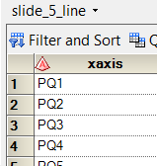
%macro xaxis_tickvalue_calculator;
%GLOBAL xtickvaluelist_&page._&postn xtickdisplaylist_&page._&postn ;

/**define xaxis tickvaluelist as macro parameter**/
data line11_xticklist_&page;
set Slide_&page._Line(keep=xaxis);
xticklist='"'||strip(xaxis)||'"';
run;
proc sql; select strip(xticklist) into :xtickvaluelist_&page._&postn separated by ' '
from line11_xticklist_&page;
quit;

/**define xaxis tickdisplaylist as macro parameter**/
data line12_xtickdisplaylist_&page(keep=xtickdisplay);
set Slide_&page._Line(keep=xaxis) nobs=nobs end=last;
ID=_N_;
xtickdisplay='"'||strip(xaxis)||'"';
do i=1 to nobs-1;
if mod(ID,3) ne 1 then do; /*automatically pick one xtickvalue from every 3*/
xtickdisplay='""';
end;
end;
if last then xtickdisplay='"'||strip(xaxis)||'"';
run;

proc sql; select strip(xtickdisplay) into :xtickdisplaylist_&page._&postn separated by ' '
from line12_xtickdisplaylist_&page;
quit;
%PUT &&xtickdisplaylist_&page._&postn; %PUT &&xtickvaluelist_&page._&postn;
%mend xaxis_tickvalue_calculator;
%if %index("&Slide_Positn",LL)>0 %then %do; %xaxis_tickvalue_calculator(postn=LL); %end;
%if %index("&Slide_Positn",LR)>0 %then %do; %xaxis_tickvalue_calculator(postn=LR); %end;
%if %index("&Slide_Positn",UL)>0 %then %do; %xaxis_tickvalue_calculator(postn=UL); %end;
%if %index("&Slide_Positn",UR)>0 %then %do; %xaxis_tickvalue_calculator(postn=UR); %end;

Contact Information:
The SAS engine is kind of complex, if anybody is interested in the logic, please feel free to contact with me, I would like to present its logic to you. I will be happy to provide necessary assistantship to you.
Kaiqing Fan
Sr. Data Scientist
Sr. SAS Tech Lead
Sr. SAS Developer
Sr. Quantitative Risk Researcher
Mastech Digital Inc.
Address: Brecksville, OH-44141
(Mobile) 504-344-7267
Personal email: fankaiqinguw@gmail.com

